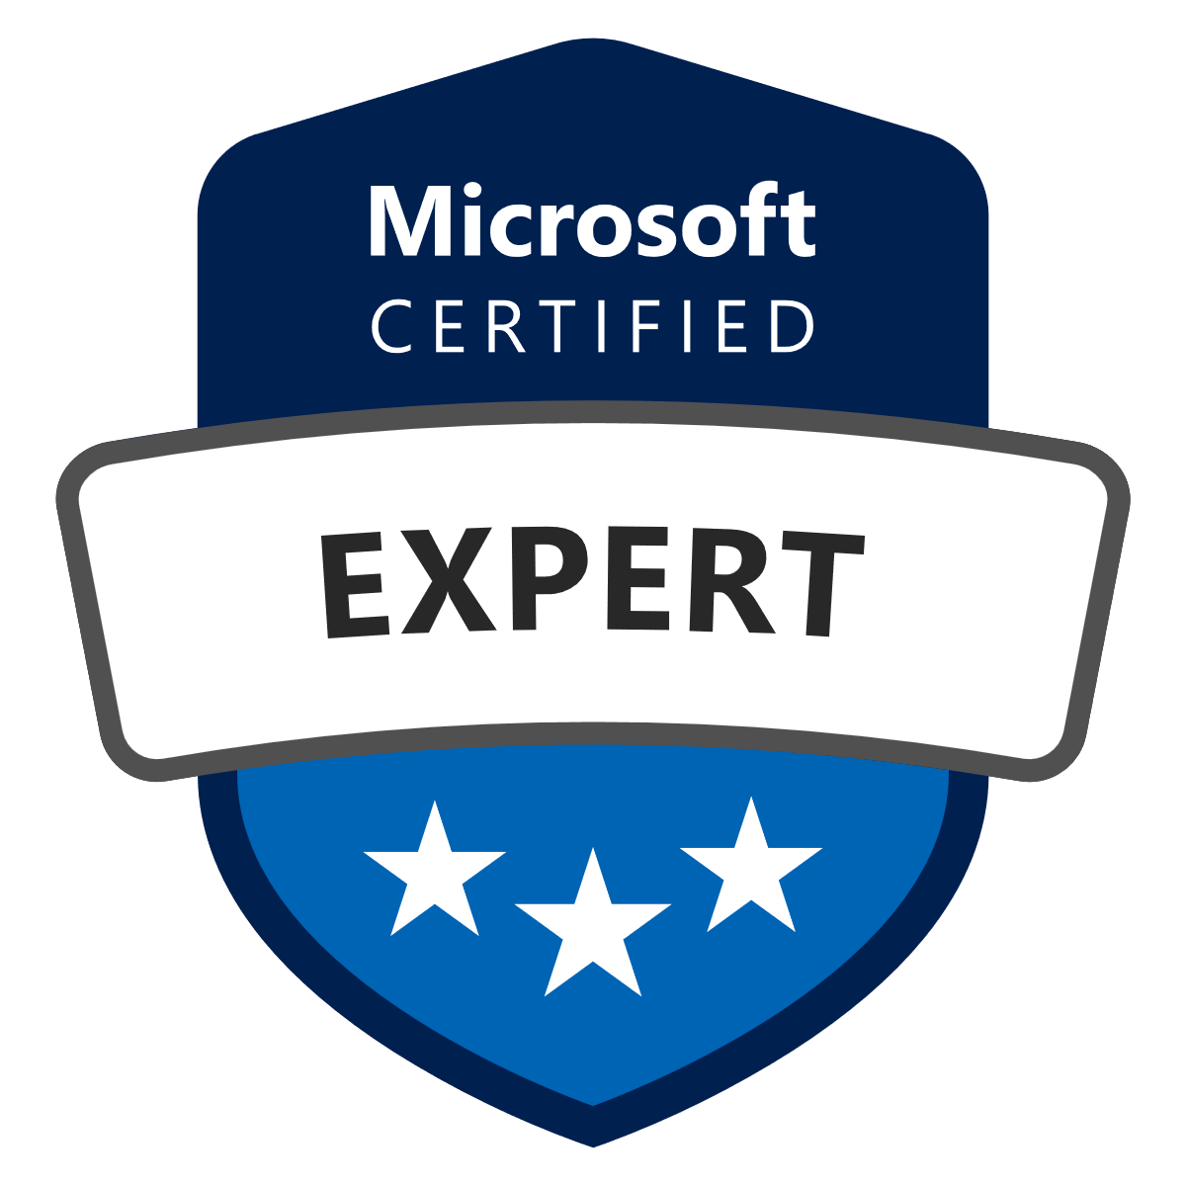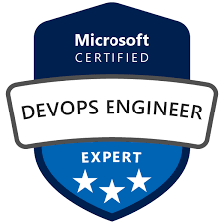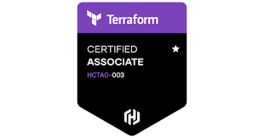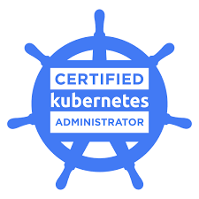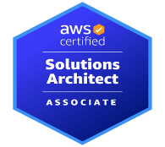

**CLOUD/DEVOPS ARCHITECT & ENGINEER (AWS, AZURE)**

**Yougander PN**

[***youganderpn@gmail.com***](mailto:youganderpn@gmail.com) ***| ©: (770) 574 – 4937 | LinkedIn***

Self-driven and highly motivated **Azure** and **AWS Cloud Specialist**, **DevOps Specialist** in **Public Cloud services, Development of Automation, Infrastructure Automation** in **DevOps Cloud space across Banking, Insurance, Finance and Healthcare** domains. Excellent subject matter expertise within the **DevOps**, **Infrastructure as a Code** (IaC), Security as a Code, Policy as a Code, Compliance as a Code, **Platform as a Service** (PaaS), SaaS, **Virtualization**, Containerization and Continuous Integration & Continuous Delivery (CI/CD)

**PROFESSIONAL SUMMARY:**

* Overall **20+ years’ experience** in **IT Infrastructure** domain consisting of **Data centers, Compute, Storage, Backups** and Disaster Recovery solutions includes **10+ years of experience** in **Azure and AWS Cloud Architect and Engineer** roles with experience in different Public **Cloud providers**. Resilient, focused and passionate professional seeking to use my professional knowledge and experience in helping to transform client’s IT **infrastructure, operations and applications** into the most innovative, scalable, highly available, secured, fault tolerant systems and also cost effective on **Public Cloud platforms**.
* **Azure DevOps** – Enable and support product teams in the transformation to DevOps processes, the use of modern tools and the consideration of **DevSecOps**.
* Experienced in provisioning **Infrastructure** via **IAC automation** tool like **Terraform**.
* Experienced in Cloud automation using AWS Cloud Formation templates. Experience in Amazon Web
* Services **EC2, ELB, S3, Route 53, EBS, VPC, AMI, SNS, RDS**, Auto Scaling, etc.
* Experience and understanding of large-scale infrastructure deployments in enterprise-wide environments
* Hands on experience in CI/CD, with tools like **Docker, Kubernetes, Jenkins, Bamboo CI/CD tools**.
* Migration to **AWS** and **Azure** public cloud
* Deployment and support on **Kubernetes platforms**, **Azure Kubernetes Service** and OpenShift environments
* Configuring and Networking of Virtual Private Cloud (**VPC, LDAP, VPN**) Written Cloud formation
* templates and deployed AWS resources using it.
* Ensure business continuity in uncommon conditions by using techniques for high availability and disaster recovery.
* Demonstrate Proof of Concept for new Solutions to the client. Perform test migrations to public cloud for customer evaluation.
* Have implemented various cost-effective solutions which resulted in huge cost savings for **IT Infra services**.
* Experienced in Project management and issue tracking tools like **JIRA**.
* Experienced in the creation of Docker containers and Docker consoles for managing the application life cycle.
* Creating Custom Docker images using Docker file for easier replication of DEV and QA environments in local machines
* Performed and deployed builds for various environments like QA, Integration, UAT and Productions
* Strong analytical and problem-solving skills and can work independently.
* Good written and verbal communication skills and strong organization skills

**In addition…….**

* ***Migration Planning***: Collaborate with stakeholders to understand business requirements and assess the feasibility of migrating on-premises systems to the cloud. Develop a comprehensive migration plan considering factors such as application dependencies, data migration, security, and compliance.
* ***Cloud Platform Selection***: Evaluate different cloud platforms (such as AWS, Azure, or Google Cloud) and choose the most suitable one based on the organization's requirements, cost considerations, and technical constraints.
* ***Infrastructure and Application Assessment***: Conduct a thorough assessment of existing infrastructure, applications, and data to identify dependencies, potential issues, and migration complexities. Determine the necessary modifications or updates required for successful migration.
* ***Environment Provisioning***: Set up and configure cloud environments and resources in preparation for the migration process. This includes provisioning virtual machines, storage, networking, and any additional services required to support the migrated applications.
* ***Data Migration***: Develop and implement strategies for migrating data from on-premises systems to the cloud. Selecting appropriate migration tools, ensuring data integrity and security, and minimizing downtime during the migration process.
* ***Application Migration***: Define and execute application migration strategies, considering factors such as application architecture, dependencies, and compatibility with the target cloud environment. Rehosting, refactoring, rearchitecting or rebuilding applications for the cloud.
* **Policy as Code:** Harness Policy as Code provides developer velocity without sacrificing compliance and standards. Policy as Code is a centralized policy management and rules service that empowers enterprises to centrally define and monitor policies that are enforced across all delivery pipelines and processes.
* ***Risk Management***: Identify and assess security risks associated with software applications, infrastructure, and processes. Develop and implement risk mitigation strategies and controls to minimize security risks.
* ***System Reliability***: Ensure the reliability and availability of software systems and services by designing and implementing robust infrastructure, monitoring, and fault tolerance mechanisms.
* ***Incident Management:*** Respond to and resolve incidents impacting the reliability or availability of systems. Perform root cause analysis and implement preventive measures to minimize the recurrence of incidents.
* ***Monitoring and Alerting***: Implement comprehensive monitoring solutions to detect issues and performance bottlenecks. Set up alerting systems to notify the team about abnormal system behavior or potential failures.
* ***Performance Optimization:*** Identify and address performance bottlenecks in systems and applications. Optimize resource utilization, improve response times, and ensure scalability to handle increasing workloads.
* ***Automation and Tooling:*** Develop and maintain automation scripts, tools, and frameworks to streamline operations, deployment, and monitoring tasks. Emphasize Infrastructure as Code (IaC) principles to enable scalable and repeatable infrastructure management.
* ***Capacity Planning:*** Assess system resource requirements and plan for capacity needs to accommodate future growth. Work closely with development teams to understand application requirements and ensure adequate resources are provisioned.
* ***Incident Response and Post-Mortems:*** Participate in incident response activities, including coordination, communication, and post-incident analysis. Conduct post-incident reviews to identify areas for improvement and implement remedial actions.

**PROFESSIONAL CERTIFICATIONS**

* ***Microsoft Certified DevOps Engineer Expert***
* ***Terraform Certified Associate***
* ***Architecting Microsoft Azure Solutions***
* ***AWS Certified Solution Architect***
* ***Certified Kubernetes Administrator***
* ***Azure Network Engineer Associate***
* ***Microsoft Certified Azure Administrator Associate***
* ***ITIL® Foundation in IT Service Management***

**TECHNICAL SKILLS:**

|  |  |
| --- | --- |
| Cloud Platform | **Amazon AWS** (EC2, S3, VPC, Cloud Formation, Cloud Watch, RDS, ElastiCache, IAM, Elastic Beanstalk, AMI, ECS), **Microsoft Azure**(AKS, Vnet, Virtual Machines, Blob, File and Table storage, Queues, ASR, ARM, Azure MFA, Azure databases), **PaaS, IaaS, SaaS** |
| Infra as Code (IaC) | **Terraform, Azure ARM templates and AWS Cloud formation** |
| Security | **Network ACL, Security Groups, Gateways, Routing Tables, Elastic Load Balancing (ELB), Secure Socket layer (SSL), Virtual Private Cloud (VPC) Virtual Private network (VPN), Vnet, Express Route, Black Duck** |
| Databases | **MySQL, PostgreSQL, DynamoDB, Elasti Cache** |
| Monitoring and Logging | **CloudWatch, Coud Trail, SIEM** |
| CI and CD Tools | **Docker**, Azure DevOps, AWS DevOps, Jenkins, GitHub, Maven, Chef |
| Automation and Configuration | **DevOps**, Continuous Integration (CI), Continuous Testing, Continuous Delivery (CD), **Kubernetes**, **Docker, Terraform, Bamboo** |
| Others | **Agile**/**Scrum**, SQL, LDAP, Powershell, Shell scripting, Python |

**WORK EXPERIENCE:**

***NordCloud (IBM Company) – Dusseldorf DE & Atlanta GA***

***Cloud Architect***

***Aug’2021 – till date***

**Roles and Responsibilities:**

* Azure Devops – Support agile transformations and accompany the entire Infrastructure deployment lifecycle. The conception and implementation of state-of-the-art technologies are also part of my job.
* Enable and support product teams in the transformation to DevOps processes, the use of modern tools and the consideration of DevSecOps.
* Deployment and support on Kubernetes platforms, Azure Kubernetes Service and OpenShift environments
* Infrastructure as Code using Terraform, Azure ARM templates and AWS CloudFormation
* Experience with Kubernetes and deployments of containerized applications/microservices
* SAP Deployment Automation Framework with Azure Devops
* Developing CI/CD roadmap and implement to the project
* Investigating new solutions to improve DevOps function
* Implementing Branching & Merging solution as per the defined target architecture
* Configure DevSecops tools using Black Duck scanning for all new builds using Bamboo CI/CD
* Developing custom scripts for build, deployment, configuration maintenance and related tasks using scripts
* Developed Python and shell scripts for automation and build release process
* Automated setting up server infrastructure for the DevOps services using Terraform , Ansible, shell and python scripts
* Regularly review and update the security configurations of your Azure DevOps services, resources, and tools.
* Implement secure baselines for your Azure resources and enforce them consistently across your environment.
* Use Azure Policy to define and enforce security configurations across your Azure resources.
* Use Azure Backup and Azure Site Recovery to protect your data and applications.
* Adopted and implemented Azure Identity Management and access control security best practices like [Treat identity as the primary security perimeter](https://learn.microsoft.com/en-us/azure/security/fundamentals/identity-management-best-practices#treat-identity-as-the-primary-security-perimeter), [Centralize identity management](https://learn.microsoft.com/en-us/azure/security/fundamentals/identity-management-best-practices#centralize-identity-management), [Manage connected tenants](https://learn.microsoft.com/en-us/azure/security/fundamentals/identity-management-best-practices#manage-connected-tenants), [Enable single sign-on](https://learn.microsoft.com/en-us/azure/security/fundamentals/identity-management-best-practices#enable-single-sign-on), [Turn on Conditional Access](https://learn.microsoft.com/en-us/azure/security/fundamentals/identity-management-best-practices#turn-on-conditional-access), [Plan for routine security improvements](https://learn.microsoft.com/en-us/azure/security/fundamentals/identity-management-best-practices#plan-for-routine-security-improvements), [Enable password management](https://learn.microsoft.com/en-us/azure/security/fundamentals/identity-management-best-practices#enable-password-management), [Enforce multi-factor verification for users](https://learn.microsoft.com/en-us/azure/security/fundamentals/identity-management-best-practices#enforce-multi-factor-verification-for-users).
* [Use role-based access control](https://learn.microsoft.com/en-us/azure/security/fundamentals/identity-management-best-practices#use-role-based-access-control), [Lower exposure of privileged accounts](https://learn.microsoft.com/en-us/azure/security/fundamentals/identity-management-best-practices#lower-exposure-of-privileged-accounts), [Control locations where resources are created](https://learn.microsoft.com/en-us/azure/security/fundamentals/identity-management-best-practices#control-locations-where-resources-are-created), [Actively monitor for suspicious activities](https://learn.microsoft.com/en-us/azure/security/fundamentals/identity-management-best-practices#actively-monitor-for-suspicious-activities), [Use Azure AD for storage authentication](https://learn.microsoft.com/en-us/azure/security/fundamentals/identity-management-best-practices#use-azure-ad-for-storage-authentication)
* Experience in using ARM templates (JSON) to create Azure services while ensuring no changes were made to the existing infrastructure.
* Cost estimation, architecture design and solutioning for new projects.
* Cloud cost management and optimization using Finops methodology
* Data Center migration to Azure Cloud.
* Customer onboarding to Azure cloud services and handholding.

***Toyota Tsusho Systems – Germany***

***Cloud Architect***

***Oct’2020 – July’2021***

**Roles and Responsibilities:**

* Provide Azure and AWS Cloud advisory
* Cloud cost optimization by looking into multiple subscriptions and recommend cost saving solutions.
* Automation using cloud native tools like Cloud formation & Terraform
* AWS Lambda - for scheduling/auto shutdown of systems to save costs and optimize the compute environment
* Provisioned 3 Tier cloud networking architecture in DEV/QA/PROD environment using AWS VPC, Network Security Groups, Load Balancers
* Architect, design, develop and implement Cloud Solutions encompassing multiple specializations, platforms, and technologies.
* Branching, Tagging release activities on GitHubCost control - Budgets for projects.
* Debug performance or other environment related issues
* Develop Dashboards for Monitoring and Alerting Rules
* Work with Dev/Data teams to document and streamline as much of their workflow as possible, including agile branching and release strategies.
* Assisted in security assessments and vulnerability management to ensure the integrity and security of systems.
* CICD pipelines include code analysis, ARM template scans
* Automate environment provisioning leveraging Infrastructure as Code (IaC)

***T Systems – Singapore***

***Cloud Consultant***

***Apr’2018 – Apr’2020***

**Roles and Responsibilities:**

* Datacenter Migration and Transformation. Cloud Computing Initiatives and Cloud adaptiveness
* Migrated SAP workloads to Azure with DB2, SQL, SAP B1, configure Azure backups and Event Hub monitoring for servers
* Understand customer’s overall infrastructure estate, IT and Business priorities and success measures to
* design implementation Architecture and solutions
* Lead the effort from the Cloud/Infrastructure team in setting up infrastructure for different environments (like Dev, QA, Pre-prod and Production) that meet up the requirements, on metal and AWS cloud (EC2 and VPC)
* Interact with business users to capture requirements, understand business, analyse gaps. Get the scope defined for the requirements.
* Providing solution to implement Continuous integration & continuous deployment solutions for medium-sized to large projects.
* Creating fully automated CI/CD build and deployment infrastructure and processes for multiple projects using Azure DevOps & AWS.
* Have setup Disaster Recovery on Azure using Azure Site Recovery for On Premises Customer Production applications.
* On Premise DC to AWS Cloud migration
* Participate in meetings with Managers and Sales teams to discuss new Business requirements and expectations of new and existing clients
* Constantly explore new solutions and technologies, integrate learning and recommendations into the development process.
* Performance tuning and optimization of IT Infrastructure components like Servers, Storage & Backups.

***American President Lines (NOL) – Singapore***

***Senior Specialist IT***

***May’2013 – Apr’2018***

**Roles and Responsibilities:**

* Designing and Implementation of IT Infra solutions that support thousands of concurrent users and disparate applications across multiple Data centres in Singapore and USA.
* Cloud Computing Initiatives to support Business IT expansion
* Actively manage, improve, and monitor cloud infrastructure on AWS, EC2, S3, and RDS, including backups, patches, and scaling.
* Configured VMs in availability sets using Azure portal to provide resiliency for IaaS based solution and scale sets using Azure Resource Manager to manage network traffic
* Designed and configured Azure Virtual Networks (VNets), subnets, Azure network settings, DHCP address blocks, DNS settings, security policies and routing.
* Deployed Azure IaaS virtual machines (VMs) and Cloud services (PaaS role instances) into secure VNets and subnets.
* Evaluate various Cloud Computing offerings for In house requirements. Lead POC on Cloud Computing Solutions.
* Designed and hosted Training Environment on AWS Cloud in a short span of time. Training content was accessed by users across the world.
* Working on Global Backup Solution project using Cloud. Experience with different cloud offerings like AWS, Google, Microsoft Azure and Fujitsu.
* Provided high availability for IaaS VMs and PaaS role instances for access from other services in the VNet with Azure Internal Load Balancer.
* Implemented high availability with Azure Resource Manager deployment models.
* Designed Network Security Groups (NSGs) to control inbound and outbound access to network interfaces (NICs), VMs and subnets.
* Major Tech Refresh Projects involving multiple Datacentres.
* Involved in administering and maintaining SAN Storage and Backup Infrastructure. Configure and manage Backup Schedules. Provide daily and weekly backup reports to management.
* Have implemented various cost-effective solutions saving over 500,000 SGD in Opex & Capex costs.
* Perform and lead POC test cases as part of new requirements and IT Infra Roadmap.

***Global Foundries, Singapore***

***Principal Engineer IT***

***Apr'2012 - May'2013***

**Roles and Responsibilities:**

* Principle Engineer role supporting Data centers, IT Infrastructure - SAN Storage & Backups
* Monitor SAN Storage performance and Capacity planning
* Administer SAN Switch, create SAN Zoning and monitor SAN Fabric
* Large scale SAN Storage deployment experience, actively involved during the planning and implementation phase of various Storage implementation projects on IBM/EMC/Netapp/HP & HDS Storage.
* Assisted in security assessments and vulnerability management to ensure the integrity and security of systems.
* Mentored and trained junior team members on SRE principles and best practices.
* Assisted in the implementation of monitoring solutions and alerting systems to improve visibility into system performance and reliability.
* Contributed to the development of automation scripts and tools to streamline operational tasks and reduce manual intervention.
* Supported incident response efforts and participated in on-call rotations to gain hands-on experience in mitigating production issues.
* Involved in Datacenter consolidation project involving SAN Storage refresh and consolidation
* Involved in DR Setup and DR Drill exercise.

***IBM via INFINITE COMPUTES, Singapore***

***Sr. Storage Engineer***

***June 2010 - April 2012***

**Roles and Responsibilities:**

* Senior Storage Engineer supporting multiple IBM clients for APAC region.
* Setup and administer IBM DS8100, DS8300 and Midrange SAN Storage
* IBM Tivoli Storage Manager Setup and Administration. Schedule Database backups, OS backups, monitoring and alerting. Provide knowledge transfer to L1 teams.
* Performed zoning and Provisioned storage from UNITY, VNX, VPLEX, HP 3PAR, HP Primera, Dell Compellent, Dell Power store, IBM storwize, IBM all-flash and Hitachi storage arrays to various Operating Systems.
* Involved in SAN Storage migration and refresh projects
* SAN Storage and Switch Firmware upgrade support
* Responsible for daily Admin, Implementation, Maintenance, and monitoring tasks.
* Responsible for managing NetApp storage arrays NetApp E series, FAS 2650, AFF-A220, and AFF 300.
* Performed the mock DR tests and real DR using snap mirror replication every Quarter.
* Created the storage pools in VNX and UNITY storage.
* Created mdisks and vdisks in IBM storwize and IBM all-flash systems.
* Migrated the data from EMC VNX, UNITY and Dell Compellent storage arrays to the Dell power store.
* Provisioned using Vplex with backend-connected UNITY and VNX including Pool Lun creation, assigning Luns to Vplex Storage groups.
* Re-discover storage, Claim Storage Volumes & assign the name, create devices and virtual volumes, Register the host initiators & export these to Vplex storage views.
* Zoned Vplex Backend ports to UNITY and VNX storage arrays.
* Generating NAR files in VNX to analyse the performance issue in VNX.
* Installed and configured the Dell Unity, ME 4024, and DELL Compellent SC storage arrays in data centers
* Managing and maintaining the Brocade and cisco switch administration.
* Performed Firmware upgrade activities on Brocade SAN Switches
* Configured brocade SAN switches in the data center and ISL connectivity between the switches.
* Configured the trunking between two switches depending on the client's requirement.
* Working on online SAN fabric migration and Removing the old switches from fabrics without downtime.
* Performing movement of brocade switches to STS as per the client’s requirement.
* Adding the new switches to the existing fabric also applying for the new port license on the brocade switches.
* Involved in host-based migrations to move the data from ISCSI storage to FC storage.
* Troubleshooting critical issues including meeting zoning requirements and the host not seeing storage management problems.
* Worked on data center consolidation projects. Planned and designed solutions to integrate the new data center with the existing environment.

***COMPUTER SCIENCES CORPORATION (CSC), India &UK***

***Sr. Storage Engineer***

***June 2006 - June 2010***

**Roles and Responsibilities:**

* SAN Storage Setup and administration
* IBM Tivoli Storage Manager setup and administration
* IBM XIV, DS8300/DS8100/DS4000 SAN Administration.
* IBM TSM Backup administration, ensure all backups are successful. Troubleshoot failed backups.
* EMC Clarion Storage Management - Host Management.
* Responsible for managing CLARIION, VNX, and VMAX Storage arrays by using Unisphere and Navisphere Manager.
* Provision and expand the luns as per the requirement.
* Adding the newly created luns to the EMC recovery point replication.
* Expanding the Luns participating in the replication.
* Activation of the DR with EMC recovery point appliance.
* Scheduling the faulty hardware replacement activities and Performing storage health checks of all storage arrays.

**Onsite Storage Migration project in UK:**

* Implementation of IBM SVC, Brocade Switches and Fabric Routing for Storage migration at Warwick & Wokingham, UK from Sep 2008 to June 2009
* Storage migration from IBM ESS to IBM DS4800 using IBM SVC. Involved in implementing IBM SVC across different datacenters, deploy Brocade switches and Fabric routing to enable data migration with minimum downtime on current production servers.

***NETWORK SOLUTIONS (IBM company), Bangalore***

***Senior Systems Admin***

***June 2004 - June 2006***

**Roles and Responsibilities:**

* Supporting Textron which was a US Based company.
* IBM SAN Storage and Brocade switch Administration
* IBM Tivoli Storage Manager Administration
* AIX Server Administration – Install AIX, install applications, ID management, File system management
* Proactively manage and maintain server, network and firewall systems
* Administer and support core Microsoft, Cisco, Citrix and VMware technologies
* Design and implement monitoring, configuration management and reporting functions that will make a hands-off environment
* Provide after-hours support for Infrastructure related emergencies as well occasional weekend Maintenance
* Maintain inventory and asset configuration documentation

***DELL International Services, Bangalore, India***

***Senior Technical support***

***Sep 2003 - Aug 2004***

**Roles and Responsibilities:**

* DELL Hardware & OS Technical support for DELL Corporate customers
* Collaborate with peers, team leads, engineers, and third-party vendors to resolve customer issues, maintaining complete ownership of issues from beginning to resolution
* Follow up with customers to ensure accurate resolution for their technical issues
* Document problems, diagnostics, interactions, next steps, and solutions implementation in a CRM tool
* Provide an extraordinary customer service experience
* Resolve Hardware and Operating System issues
* Operating System patching and Root Cause Analysis for any Hardware issues

***Hinduja TMT, Bangalore, India***

***Customer Support Representative***

***Aug 2002 - Sep 2003***

**Roles and Responsibilities:**

* Install software and necessary applications for workflow.
* Document hardware and software updates.
* Test compatibility of new programs with existing ones.
* Consults with users to determine appropriate hardware and software needs and assists in placing orders.
* Prepare reference material for users by drafting operation instructions

**EDUCATIONAL DETAILS:**

* **Masters** in MBA(IT) from Sikkim Manipal University - 2011
* **Post Graduate Diploma** in E-Commerce from Bharathidasan University, (2001-2002)
* **Bachelors** in Computer Science BHS First Grade College, Bangalore University - Bangalore (1998 - 2001)

**REFERENCES UPON REQUEST**